Exercise – 5 Configuring the Spring IoC Container

Name: Shubham Sangram Bej

Aim
To configure the Spring IoC Container using an XML configuration file and manage bean dependencies in a Library Management application.

Scenario
The Library Management application requires a centralised configuration for managing beans and dependencies using the Spring IoC Container.

Objective
- Configure the Spring IoC Container.
- Create XML-based bean definitions.
- Define BookRepository and BookService beans.
- Implement Setter Dependency Injection.
- Load and test the Spring context.

Software Requirements
- Java JDK 21
- Apache Maven
- Spring Framework 5.3.39
- IntelliJ IDEA

Theory
The Spring IoC (Inversion of Control) Container is responsible for creating, configuring, and managing the lifecycle of objects known as beans. Instead of manually creating objects using the new keyword, Spring instantiates and injects dependencies based on the configuration provided in the XML file.
In this exercise, the BookRepository and BookService classes are configured as Spring beans. The BookRepository object is injected into the BookService using Setter Dependency Injection. The application loads the Spring container using the applicationContext.xml configuration file and retrieves the required bean to demonstrate successful dependency management.

Procedure
- Created a Maven project.
- Added the Spring Context dependency in pom.xml.
- Created the BookRepository class.
- Created the BookService class with a setter method for dependency injection.
- Created the applicationContext.xml configuration file.
- Defined the BookRepository and BookService beans.
- Configured Setter Injection using the property tag.
- Created the LibraryApplication class.
- Loaded the Spring IoC Container.
- Retrieved the BookService bean and executed the application.

Files Used
- BookRepository.java
- BookService.java
- LibraryApplication.java
- applicationContext.xml
- pom.xml

Output

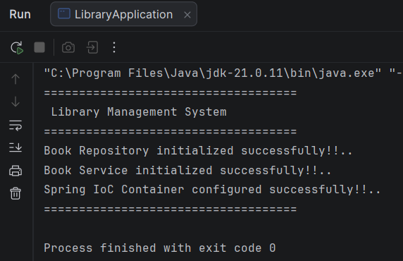

Screenshots
- Project Structure
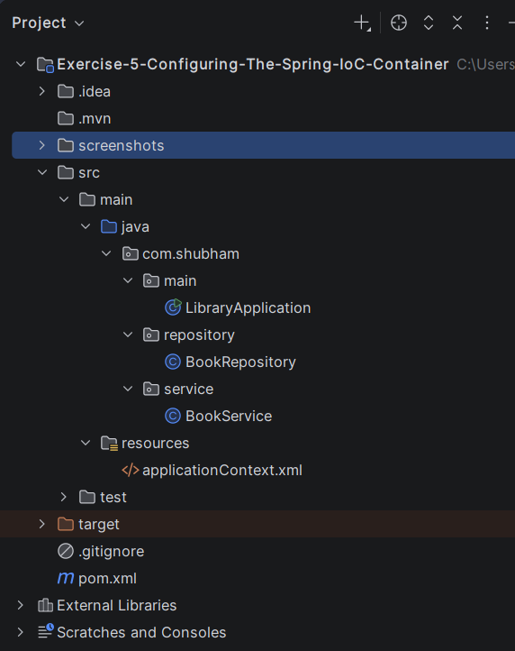

- pom.xml
<?xml version="1.0" encoding="UTF-8"?>
<project xmlns="http://maven.apache.org/POM/4.0.0"
xmlns:xsi="http://www.w3.org/2001/XMLSchema-instance"
xsi:schemaLocation="
http://maven.apache.org/POM/4.0.0
https://maven.apache.org/xsd/maven-4.0.0.xsd">
<modelVersion>4.0.0</modelVersion>
<groupId>com.shubham</groupId>
<artifactId>exercise-5-configuring-the-spring-ioc-container</artifactId>
<version>1.0-SNAPSHOT</version>
<properties>
<maven.compiler.source>21</maven.compiler.source>
<maven.compiler.target>21</maven.compiler.target>
<spring.version>5.3.39</spring.version>
</properties>
<dependencies>
<dependency>
<groupId>org.springframework</groupId>
<artifactId>spring-context</artifactId>
<version>${spring.version}</version>
</dependency>
</dependencies>
</project>

- BookRepository.java
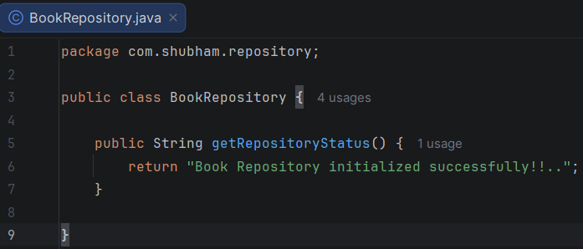

- BookService.java
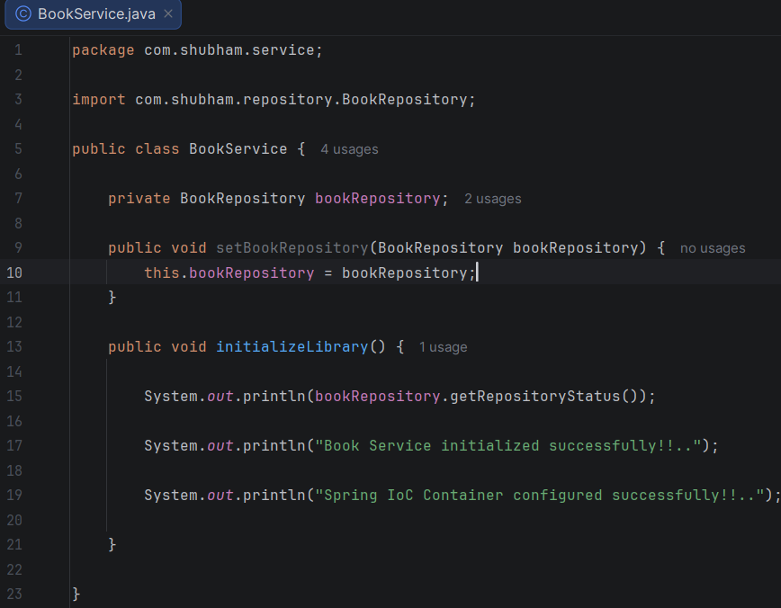

- applicationContext.xml
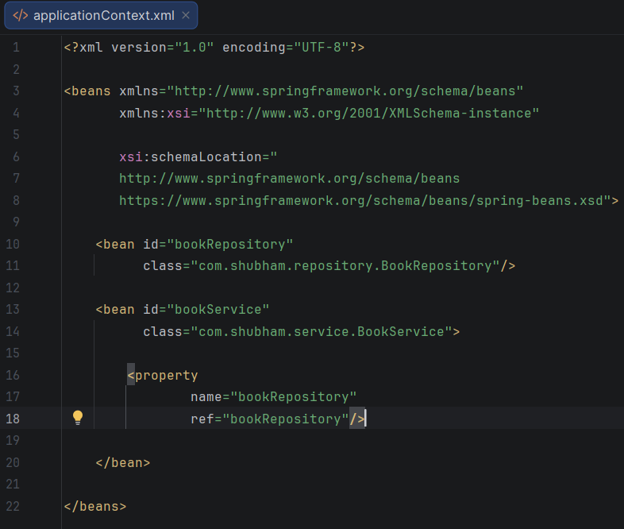
- LibraryApplication.java
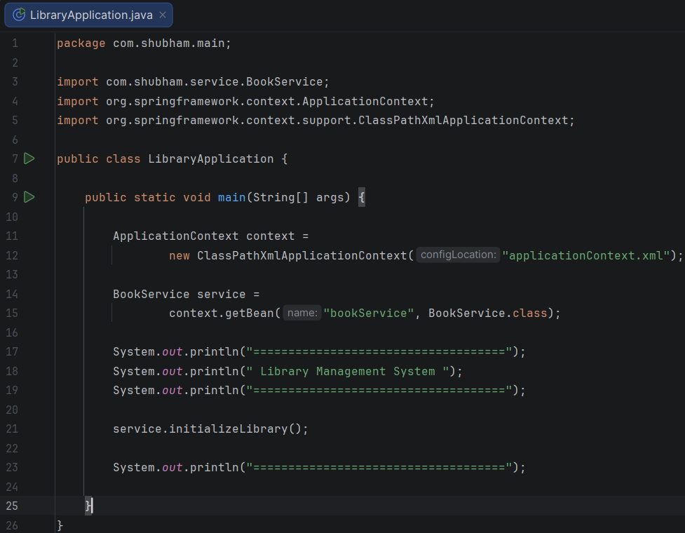

Result
The Spring IoC Container was successfully configured using an XML configuration file. The BookRepository bean was injected into the BookService bean using Setter Dependency Injection, and the application executed successfully.

Conclusion
This exercise demonstrated the configuration of the Spring IoC Container using XML, bean creation, dependency injection through setter methods, and successful retrieval of beans from the Spring context.

